**Culture | Home Entertainment**

**文化| 家庭娱乐**

（英文部分选自经济学人202200813期文化版块）

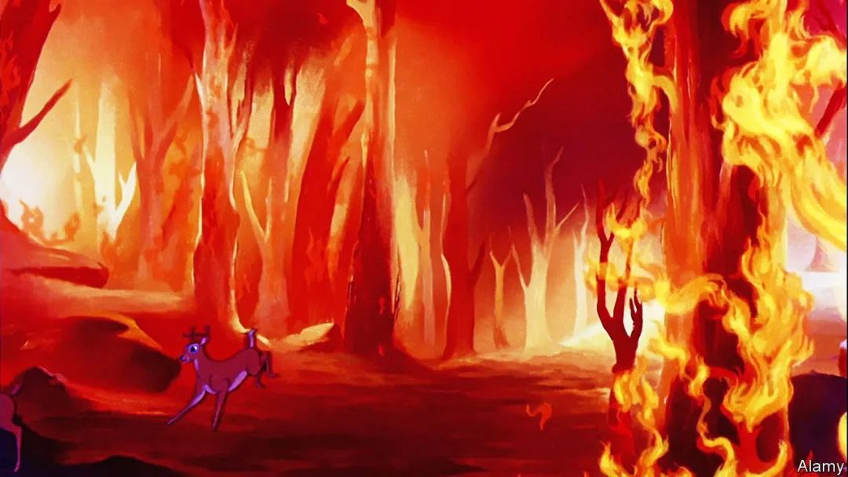

Culture | Home Entertainment

文化| 家庭娱乐

**“Bambi” offers a horrifying portrait of eco-catastrophe**

《小鹿斑比》展现了可怖的生态灾难景象

In the **animated film** of 1942, **careless humans** **set off** an apocalyptic forest fire在这部1942年制作的**动画片**中，**鲁莽的人类引发了**宛如世界末日的森林大火

What is the most famous scene in “Bambi”? Eighty years on from the film’s premiere in August 1942, there is only one answer: it is the scene in which Bambi’s mother dies. The Walt Disney cartoon—ostensibly about a deer gambolling around an idyllic forest—has traumatised generations of youngsters. What is even more impressive is that the scene doesn’t actually exist. Whatever memory viewers might have, the film doesn’t explicitly show the death of Bambi’s mother.

《小鹿斑比》最著名的情节是哪一段？1942年8月该片首映后的80年间，这个问题的答案都只有一个，那就是小鹿斑比母亲身亡的场景。这部由华特·迪斯尼制作的动画片描绘了一只小鹿在田野山林间纵情嬉戏的故事，但却给几代年轻人留下了心理阴影。更加突出的一点是，影片实际上并没有悲惨的画面。无论观众对影片留下何种记忆，影片都没有明确展现斑比母亲的死亡。  
About 40 minutes in (no, it’s not in the first ten minutes, although many share that false memory, too), doe and fawn are running from unseen hunters through a snowy meadow. A gunshot is heard. Bambi races back to his shelter in “the thicket”, only to realise, after a second of elated relief, that he is alone. His majestic father then **looms over** him in silhouette and murmurs: “Your mother can’t be with you any more.” And that’s that. There are no poignant last words, no mourning period or slow recovery. The film immediately cuts to a tra-la-la-ing song about falling in love in the springtime, and Bambi’s mum is never mentioned again. For Bambi, Thumper and their woodland friends, **death is just an everyday part of growing up**. The film’s viewers may be perturbed by this attitude, but the animals aren’t.

电影开始大约40分钟后（并非在影片前10分钟，虽然很多人都持有这种错误印象），鹿妈妈和小鹿在白雪皑皑的草原上奔跑，躲避暗处的猎人。一声枪响传来，斑比飞快地跑回灌木丛里的“避难所”，刚松了一口气，就发现只有自己跑回来了。然后，斑比的父亲出场了，他威严的身影笼罩着斑比，喃喃道：“你的母亲以后不能和你在一起了”。（母亲去世这个场景）到这里就戛然而止，没有凄美的遗言、悲痛的哀悼和缓慢的恢复。影片直接切换到一首欢快的春日恋歌，然后就再也没有角色提到斑比的母亲。对斑比、桑普和他们的森林小友来说，**死亡只是成长过程中稀松平常的事**。观众也许会对这种态度感到不安，但动物并不会。

**This brisk lack of sentiment is typical of a film which is far bolder than its fluffy reputation might suggest**. **Adapted from** a novel by Felix Salten, an Austro-Hungarian author, Disney’s fifth feature-length cartoon is a gorgeous tapestry of different animation techniques. There is no adventure plot or triumph-over-adversity theme **imposed on** the art: David Hand, the **supervising director**, simply made a 70-minute chronicle of a wobbly legged deer’s learning about life and death.

**轻快而不感伤是这种电影的典型特征，而这类电影远比它（作为儿童电影）又软又甜的名声大胆得多**。《小鹿斑比》**改编自**奥匈帝国作家费利克斯·萨尔滕（Felix Salten）的小说，是迪士尼制作的第五部动画长片，也是多种动画技术的集大成者。这部作品没有硬塞冒险情节，也没有**强加**战胜逆境的主题：**监制导演**大卫·汉德（David Hand）不过用70分钟的时间记录了一只懵懂的小鹿对生死的认知过程。

**Watching it now, in the middle of a dangerously hot summer**, **the most horrifying sequence is the one in which a wildfire consumes the forest**. In later Disney cartoons, this sort of eco-catastrophe would be caused by lightning (as in “The Jungle Book”) or by greedy hyenas (“The Lion King”). In “Bambi”, however, humans **are squarely to** blame. Not that any people are depicted: Bambi is warned of a species called “Man”, but, just as Hand omitted the killing of the fawn’s mother, he chose not to show any humans on screen.  
**当下正值酷暑，这个时候观看《小鹿斑比》，最让人感到恐惧的莫过于影片中山火吞噬森林的场景**。迪士尼后来的动画作品可能将这种生态灾难归因于闪电（如《森林王子》）或贪婪的鬣狗（《狮子王》），然而《小鹿斑比》呈现出的灾难却明显是人类造成的。倒不是说影片当中出现了人类：其他动物警告斑比要警惕一种叫做“人”的物种，但是正如汉德略去了斑比母亲遇害的镜头一样，荧幕上没有出现哪怕一个人类。

**Instead, the flames from an unattended campfire are blown into a tree**, **and then an unstoppable blaze turns a green paradise into an inferno**. No one in particular is responsible. There is no snarling Captain Hook, Maleficent or Cruella de Vil to reassure viewers that only evildoers destroy the environment. Man in general, it seems, is so careless that he would rather lay waste to nature than go to the effort of putting out a campfire.

**疏于看管的营地篝火被风吹到了树上，然后火势蔓延开来，势不可挡，将绿茵天堂变为赤焰地狱**。影片没有表明谁是罪魁祸首，也没有为了安抚观众而设置例如咆哮的虎克船长、女巫梅尔菲森特和库伊拉之类的邪恶角色来毁坏环境。影片似在暗示，人类这个群体就是如此没心没肺，宁见自然付之一炬，也不肯用心扑灭营地篝火。  
  
注释：Captain Hook, Maleficent or Cruella de Vil: 虎克船长、女巫梅尔菲森特和女巫库伊拉分别为迪士尼动画影片《小飞侠》、《睡美人》和《101斑点狗》中的大反派。

Again, the film doesn’t have any wailing or gnashing of teeth. No one delivers any speeches about the injustice of it all, and no one expresses the hope that it might not happen again. **Wildfires are just one more thing that the animals have got used to**. And now humans must get used to them as well: a thought as harrowing as the demise of Bambi’s mother.

与斑比母亲去世时一样，此时片中既没有谁呼天抢地，也没有谁咬牙切齿；既没有谁就森林遭遇的不公发表演说，也没有谁对此类事件不再发生表达期许。**森林野火不过是动物们已经适应的又一件事罢了**，可现在轮到人类来适应它了：此事堪比斑比丧母，光是想想就令人揪心。